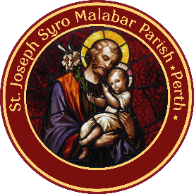
St. Joseph Syro-Malabar Parish, Perth, WA
Parish Registration Number
Name of the Candidate
Baptism/Christian Name
Date of Birth |  |  |  |  |  |  |  | Male / Female (Please circle)
2020 School Year
Sacraments Received | Baptism |  | Reconciliation |  |  |  | Holy Communion |  |  |  |  |  |  | Confirmation
Catechism Centre | Embleton |  |  | Joondalup |  | Maddington |  |  |  |  |  |  | Willetton |  | Other
Name of Father |  |  |  |  |  |  |  |  | Mob. No.
Father’s Email Id
Name of Mother |  |  |  |  |  |  |  |  | Mob. No.
Mother’s Email Id
Emergency Contact No.
Family Unit Name
Residential Address
Is your child receiving the Sacraments at Maddington? If yes, please tick which sacrament. | YES | First Holy Communion |  |  |  |  |  |  |  |  | Confirmation
 | NO
Does your child have any medical conditions to be taken care of? | Food Allergy |  |  |  | Medication |  |  |  |  | Other
(Eparchy of St. Thomas the Apostle, Melbourne)
Email: holyfamily.smcc@gmail.com Tel: 08 94931703

FIRST HOLY COMMUNION AND CONFIRMATION
REGISTRATION FORM 2020

I …………………………….…………. hereby state that the above information is correct to the best of my knowledge.

Signature of the Parent _____________________ Date _________________

